Mobility in the Corridor
Northwest area stakeholders have established a multimodal vision whereby people can safely and reliably access and move throughout the corridor by walking, bicycling, riding transit, and driving. This multimodal corridor vision was established through the CO 119 Multi-Modal Planning and Environmental Linkages (PEL) Study, which identified numerous project elements being advanced as separate projects by corridor stakeholders.
CO 119 Safety and Mobility Improvements Project is being designed to integrate with these other projects on the Corridor:
- CO 119 Bikeway Design Project
- City of Boulder 28th Street Improvements Project
- Commuting Solutions First & Final Mile Study
- City of Longmont Coffman Street Busway
- City of Longmont CO 119 and Hover Street

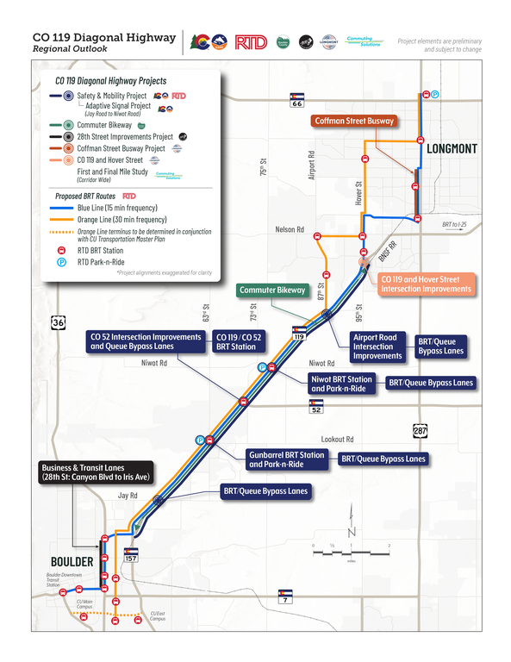
(Click image to enlarge)

